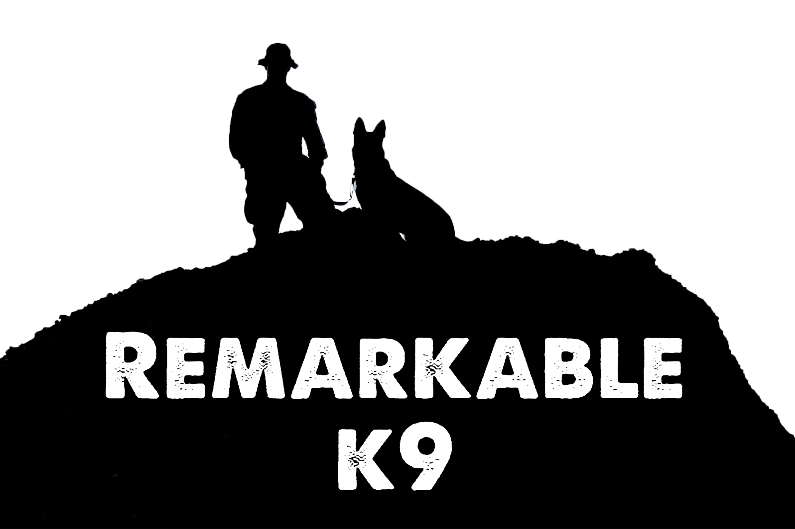

Dominant Canine

Just like people canines have personality, strengths and can have leadership skills. While the typical relationship with a canine is dictated by the human being the leader or Alpha. Sometimes a strong-willed canine will try to assert itself as the leader on its pack (that is you). This is not a desirable or beneficial relationship. Careful and deliberate training and leadership on your part can eliminate this issue leading to a friendly and rewarding relationship. These five easy steps consistently applied will solidify your leadership position and relationship with your canine.

Be Calm and Assertive- Do not get excited or angry when things go wrong. Repeat training when needed and above all be calm and consistent when interacting with your canine. If your canine sees you are stressed or unsure they can feel the need to step in and take charge. If they see you are calm and stable they will know everything is “okay.” Your leadership will provide security and stability to their life.

Set Rules and Limitations- This is a good way to assert yourself over your canine and develop several control points to show your canine who is the leader. While these are all good suggestions perhaps you have some of your own rules you wish to develop.

- When going for a car ride do not allow the canine in the car until you give them the command to enter.
- Keep the canines out of certain areas of the house. Perhaps you do not want the canine in the bedrooms, upon the beds or in the formal dining area. Whichever rooms you decide upon, be consistent and ensure everyone knows the rules so the canine will not get confused.
- If your canine likes to chew on rawhide bones make them go in the backyard when enjoying their treat.

Petting and Affection- The dominant canine may be more aloft or solitary than you expect and that is okay. The important thing is to give the canine some space and let them come to you instead of you going to them. This will reinforce your Alpha position and dominance. When they want affection and attention they will come to you. If you go to them it will put them in the leadership position. This does not mean you need to completely ignore them. Just remain faithful to your plan, believing in it, and understand you want your canine coming to you more than you going to them.

Feeding- Food is an ideal tool for establishing your dominance. Remember in a pack, the dominant canine eats first. When you control meal time you control the canine.

- Make your canine sit while you are giving them their food and ONLY let them eat upon your command. Select a single word as the command to use. When you issue this command, they can eat. Everyone should use this same word.
- Do not allow your canine in the dining area when you and your family are eating. Set and enforce boundaries and then just ignore the canine until you are finished eating. Feed your canine after you eat.

Chore Time – Every pack canine has a job to do and your canine should be no different. Giving your canine, a job will keep them busy and makes them feel a member of the pack. It lets them know you are the boss. It could be as simple as carrying a back pack when you go for a walk or something as ambitious as training them to bring in the daily newspaper. Perhaps always sitting in the way back in your car or walking with you to get the mail. Again, whichever chore you choose be consistent so your canine knows this is their job or role in the pack.

Remember calmness and assertiveness consistently applied will show your canine who is the boss. Setting rules and ensuring they are followed will help you to develop a healthy relationship. This will greatly increase your and your canine’s happiness and lead to a more peaceful and calm household.

Remarkable K9 Solutions

